Quantified Student

Project plan

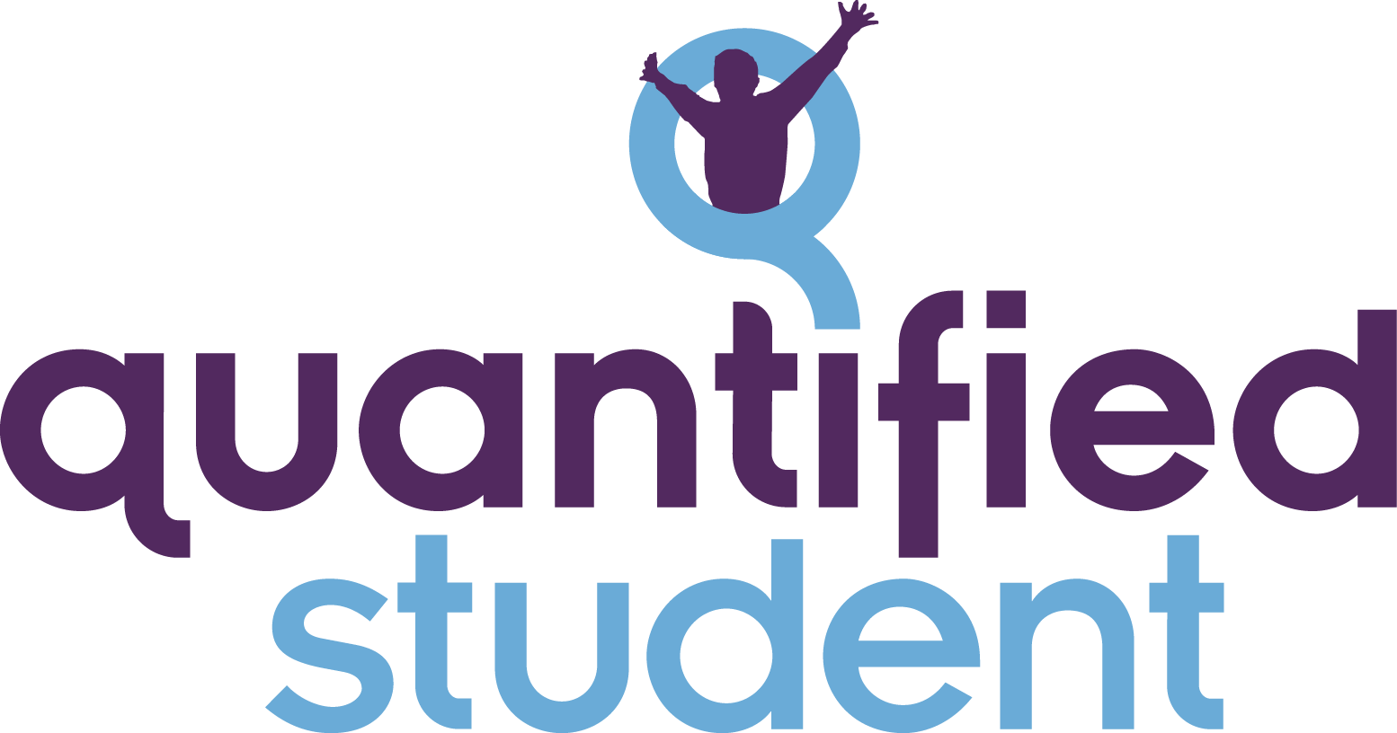

Created by N.Geilen

Checked by K.Janssen & J.Maas

# Content

**Content** **1**

**Version History** **2**

**1 Introduction** **3**

**2 Stakeholders** **4**

**3 Team** **4**

**4 Goal** **5**

**5 Sub-projects** **6**

**5.1 API** **6**

**5.2 Dashboard** **6**

**5.3 Data sources** **6**

**6 Team agreement** **8**

6.1 Coding conventions 8

6.2 Standups / Scrum Board 8

**7 Deliverables** **9**

**8 Definitions, Acronyms, and Abbreviations** **10**

# 

# Version History

| Version | Date | Author | Comment |
| --- | --- | --- | --- |
| 0.1 | 06-04–2022 | N.Geilen | Start document |
| 0.2 | 14-04-2022 | N.Geilen | Changes after feedback stakeholder and group members |
| 0.3 | 26-04-2022 | J.Maas | Improve introduction |

# 

# 1 Introduction

The Quantified Student (QS for short) project focuses on helping students with their development and optimizing their performance with the help of collected data. The collected data will be shown in a dashboard where the student can see it. After which, the student can conclude where and how to improve their workflow. For example, the system can show when it is the best time to work for the student.

# 

# 2 Stakeholders

Our stakeholder for this project is Eric Slaats.

# 3 Team

Our group representative is Jelle Maas who fills the role of scrum master during meetings. Other members of the projects are:

| Name | Email | Role |
| --- | --- | --- |
| Jelle Maas | jelle.maas@student.fontys.nl | Project leader, lead on the smartwatch |
| Koen Janssen | k.janssen-ab@student.fontys.nl | Lead for the API |
| Neal Geilen | n.geilen@student.fontys.nl | Full stack developer for the API and Dashboard |
| Jasper van den Meiracker | j.vandenmeiracker@student.fontys.nl | Lead for the dashboard |
| Gijs Horsten | g.horsten@student.fontys.nl | Developer smartwatch |

# 

# 4 Goal

For the project and future sub-projects the following vision applies:

**Quantified Student has the goal to help students optimize their performance. We want to achieve this with the help of data gathering and presentation of the data to the student.**

Mission statement this semester.

**The goal of this project will be to gather useful data about a student like health data from the smartwatch. The data will be presented with other data sources in a visual way to the end-user on a dashboard that is integrated into Canvas.**

# 5 Sub-projects

## 5.1 API

The API will be the brains of the QS project. It will receive all the data from all connected data sources and the dashboard can ask the API for data.

The most important things for the API are the following.

* **Scalability**: The API will have multiple data sources that will provide data. It needs to be easy to add new data sources to the API.
* **Security**: Due to the highly sensitive data, the connected sources can generate, it is necessary to adhere to modern security standards.
* **Privacy**: Due to the highly sensitive data and personal data, the connected sources can generate, it is necessary to follow the [GDPR](https://gdpr.eu/). **The data from a student will not be shared with Fontys or teachers/coaches or other third parties and services.**

## 5.2 Dashboard

The web application that will visualize the data is going to be integrated into Canvas. This application will be placed inside canvas with the help of the LTI interaction that Canvas has. The dashboard will need to have the same three main points as the API. Mainly the scalability of the dashboard is important so that new data sources could be visually presented.

## 5.3 Data sources

QS will use multiple different data sources to gather data. The base of these data sources will consist of the following.

* Smartwatch, biometrics
  + An smartphone application with a smart band that will collect the following: Heart rate, Stress, Oxygen saturation, Sleep, Steps
* Screen time,
  + With an application we could collect the mobile screen time of the student.
* Canvas
  + Canvas holds all the information about a student's assignments and grades. This data is an indicator of how good the student is doing
* WiFi attendance
  + With the help of the WiFi/Hotspot network on Fontys locations data will be collected to determine how long and when a student was on location.
* Open Maze
  + TBD
* Open Data
  + Open data is a broad source of public information. This can be weather information or public transit delays.

To determine all kinds of data that would be collected we could start a sub-project that will research all other projects for data.

# 

# 6 Team agreement

Within the team, we have agreed to the following:

## 6.1 Coding conventions

At this moment we don’t know if we are creating our own backend application, so this will be determined later.

## 6.2 Standups / Scrum Board

Standups are on location at Strijp-TQ every Wednesday. The scrum board is a physical to-do board at TQ.

# 

# 7 Deliverables

* An application that will be the base of QS. This can be a self-made API or existing service or software.
* An application that can visualize the data inside Canvas with the help of LTI.
* An Android application that can support smartwatches and can gather screen time information

# 

# 8 Definitions, Acronyms, and Abbreviations

| Abbreviation | Meaning |
| --- | --- |
| TBD | To be discussed |
| QS | Quantified Student |
| LTI | TBD |